Dharma Devi-2025-04-10

**1. Enable Required APIs**

**2. Create a BigLake GCS Connection**

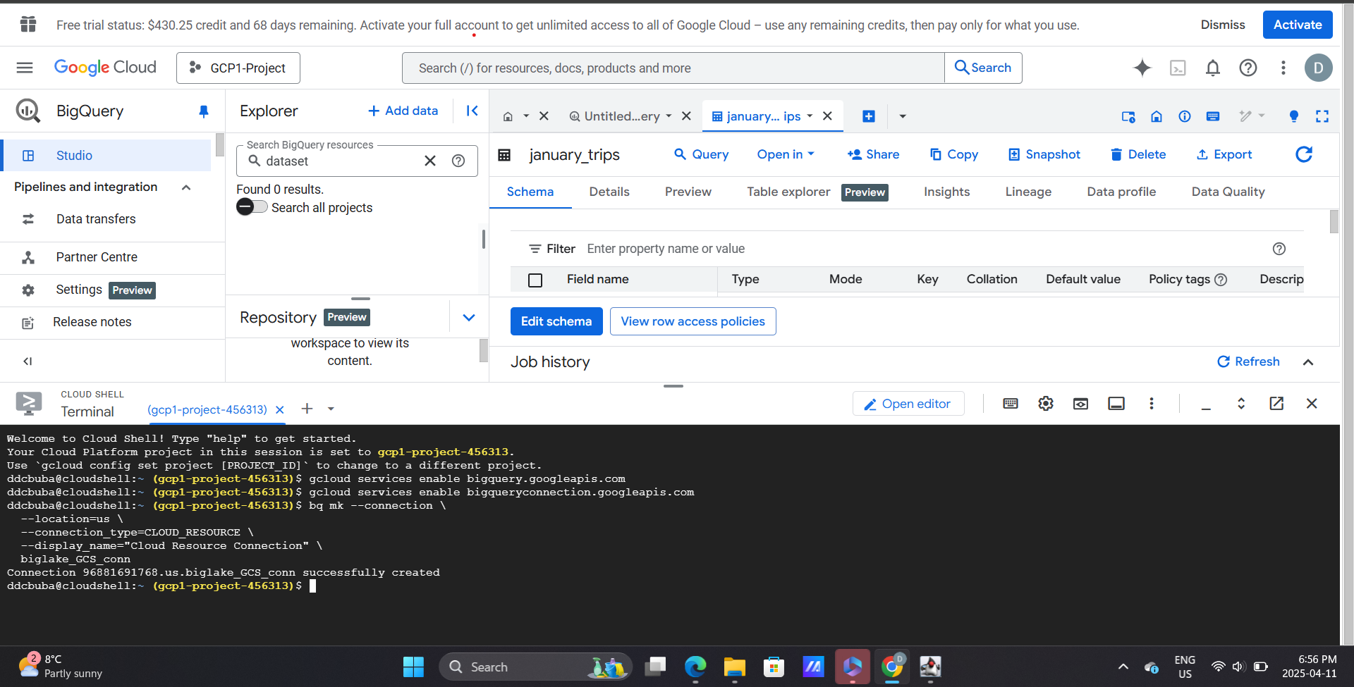

**3. Find the Auto-Created Service Account**

